PRESS RELEASE

THE 43RD ASEAN SUMMIT 2023 COMMUNICATIONS AND MEDIA TEAM

No.02/SP/TKM-ASEAN2023/ENG/8/2023

MCI Invites General Public to Promote 43rd ASEAN Summit 2023 via Social Media

Jakarta, 29 August 2023 – Social media has become one of the channels that can shape and influence public opinion. The strengths of social media must also be utilized, including in disseminating information on Indonesia's 2023 ASEAN Chairmanship.

The orchestration of public information conducted by central and regional governments have been increasingly become massive and well-coordinated with the many communication channels.

It was stated by the Director of Public Communications Governance and Partnerships of the Directorate General of Public Information and Communications), Ministry of Communications and Informatics (MCI), Hasyim Gautama, at a technical mentoring session (Bimtek) on Government Social Media Management ahead of the 43rd ASEAN Summit 2023, Jakarta, Tuesday (29/8/2023).
Hasyim believed that social media is an effective choice for disseminating various information in fast approaching 43rd ASEAN Summit 2023 in Jakarta on 5-7 September2023. Apart from its wide reach, he said, people of cross-generations are now using social media as a channel for seeking information.
Based on Hootsuite and We are Social surveys in 2023, sixty percent Indonesians, or the equivalent of 167 million people, use social media as a means of information seeking and daily communication. "It means, most Indonesians prefer social media over other communication channels," said Hasyim.
It also encourages the Ministry to take part in utilizing social media as a means of disseminating information regarding the 43rd ASEAN Summit 2023. The content and narrative are also made simple to make it easier for people from various walks of life to understand the context and benefits of Indonesia's leadership in the region and even the world.
"[It] delivers information with a simple but meaningful narrative regarding the 43rd ASEAN Summit 2023. So that the public understands and doesn’t get caught up in the circulating hoax information or mis-information g, especially on social media," said Hasyim.
Increased public understanding of every substance that is being discussed and fought for to become an agreement at the Summit, said Hasyim, will certainly reduce the chance for hoaxes and misinformation to spread.
"We’ll get double results: building a positive narrative from Indonesia's chairmanship in ASEAN and building the nation's reputation (nation branding)," he said.

​Therefore, Hasyim hoped that all elements, not only the government, can participate in building better public spaces, especially in supporting the success of the 43rd ASEAN Summit 2023. This collaboration has been proven during the 42nd Summit in Labuan Bajo which took place smoothly and successfully. This success was also able to highlight Indonesia's leadership at the global level.
"[We need] stronger enthusiasm and collaboration in echoing the 2023 ASEAN Summit because the success of Indonesia's chairmanship at the 2023 ASEAN Summit is judged by good public communication," concluded Hasyim.
The theme for Indonesia's 2023 ASEAN Chairmanship is "ASEAN Matters: Epicentrum of Growth". Through this theme, Indonesia aspires to ensure that ASEAN is an organization who plays a role for the region and the world.

Indonesian President Joko Widodo will open the 43rd ASEAN Summit and chair more than twelve meetings. The series of meetings cover the 43rd Summit in plenary and retreat format, the 26th ASEAN-China Summit, the 24th ASEAN-South Korea Summit, the 26th ASEAN-Japan Summit, and the 11th ASEAN-United States Summit.

The other meetings are the ASEAN-Canada Summit, the 26th ASEAN Plus Three Summit, the 20th ASEAN-India Summit, the 3rd ASEAN-Australia Summit, the 18th East Asia Summit (EAS), and the 13th ASEAN-Union Summit. Nations (UN). (Toro/Donna/TR)

***

For more information, please contact:

Director General of Public Information and Communications of the Ministry of Communications and Informatics – Usman Kansong (0816785320).

Find more information at http://asean2023.id, https://infopublik.id/kategori/asean-2023, and https://indonesia.go.id/kategori/ragam-asean-2023

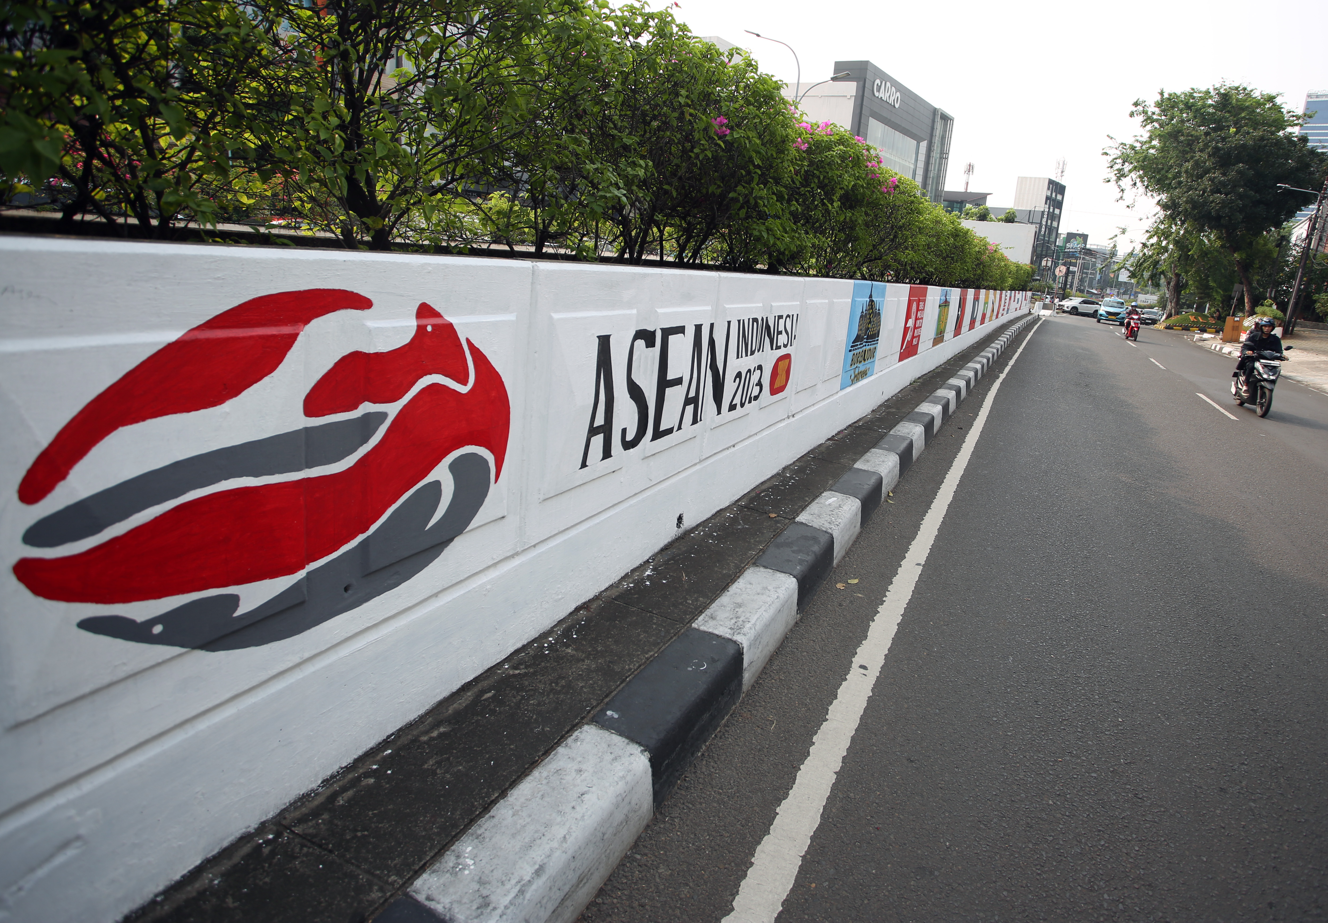

Mural with ASEAN Summit theme on the underpass wall of Jalan Iskandar Muda, Jakarta, Wednesday (26/7/2023). The mural was made to welcome the 43rd Summit of the Association of Southeast Asian Nations (ASEAN), which will take place from 5 to 7 September 2023 in Jakarta. ANTARA FOTO/Muhammad Iqbal/nym.

